MORE INFO

Set consists of:
- 10 x Seraphim Solar Panels SRP-6PB 260W
- 5 x Blue Solar 75/15 MPPT charge controller
- 1 x BMV-700 Precision Battery Monitoring
- 4 x Victron AGM battery 220Ah
- 1 x inverter Phoenix 3000/24
- 1 x Electrical PV switchgear
- Solar cable 4mm2 ~ 100m
- 5 x MC4 connectors
Presented solar energy system enables to power supply of 3000W continuous power.
Used components from leading companies Victron Energy and Sunrise Solartech warranty the highest durability and quality. Increasing battery system from 12Vto 24V ensure decrease of loss and charge controller, with function of tracking the power point, influences on best efficiency and speed of charging the batteries.
The Victron Energy AGM batteries used in system, enables proper work both during slow discharging and fully loaded. AGM batteries are adapted to cyclic work as well as to deep discharge.
255W solar panels connected in pairs to charge controller MPPT, provide uninterrupted charging of battery set. The idea of dividing 10 solar panels to 5 charging controllers has economic as well as technical advantages.
In case of shading one of the solar panels the whole system is not shutting down, as it happens in solar power plants without batteries, but the rest of solar panels works normally.

Solar panels 260W
Batteries AGM capacity 4 x 220Ah
Voltage and amps: VDC 5x 24V/15A PWM
Charging time and discharging time: 1500W/230V during 7h / Charging time about 4,5h (11 kWh)
Battery durability 400 cycles or 4-6 years of cyclic work
 Voltage 230V sinusoidal max 2500W
 Ekological power source

10 x Seraphim Solar Panels SRP-6PB 260W
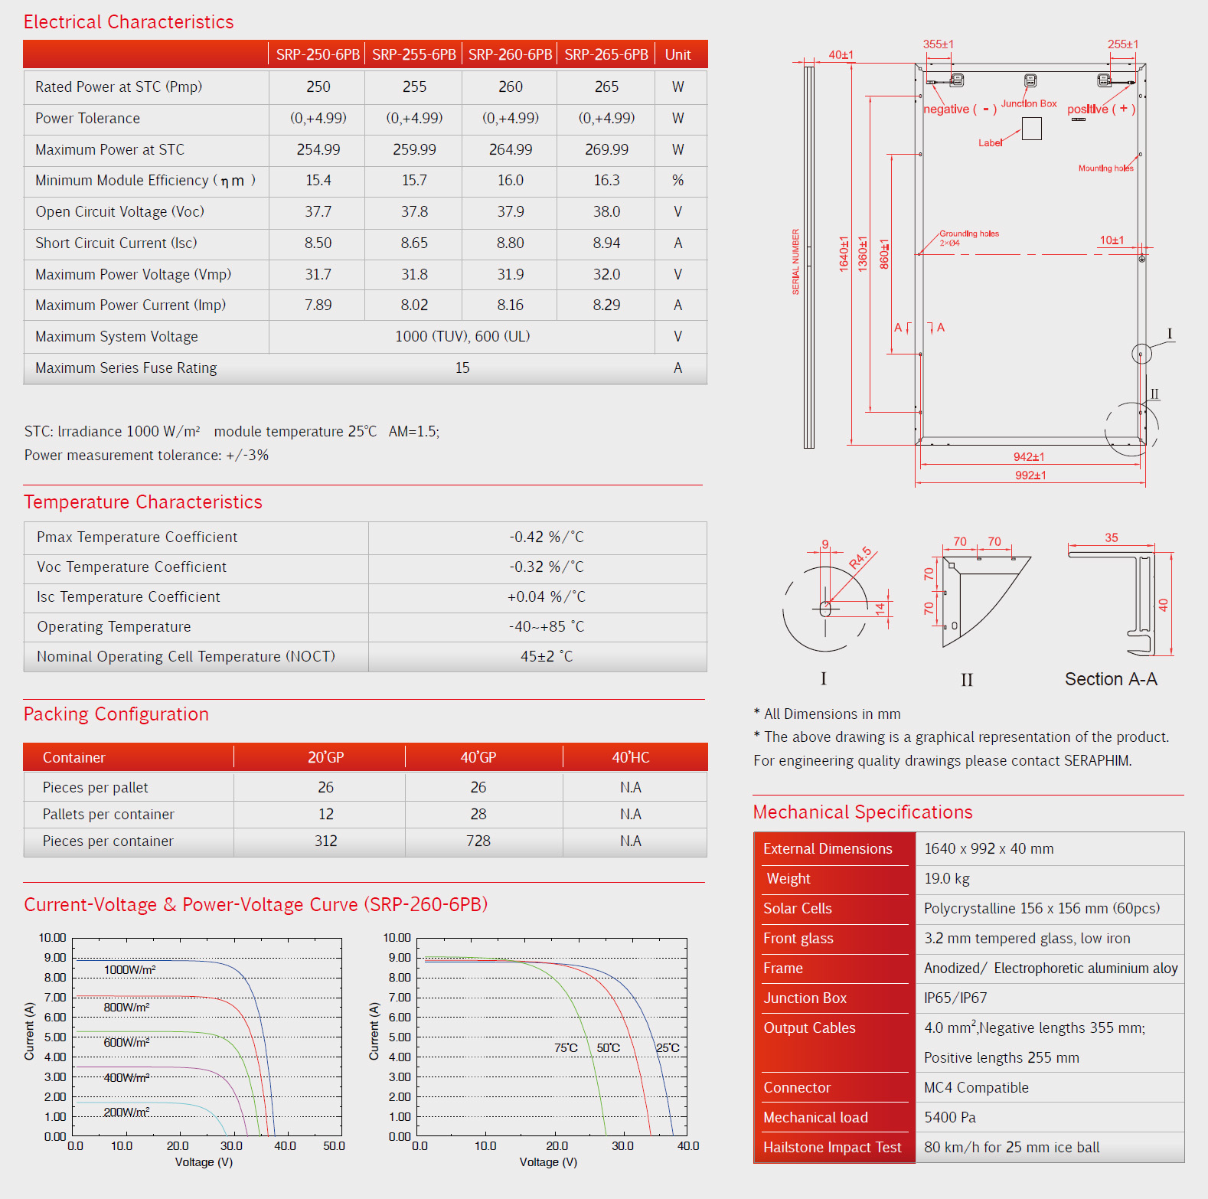
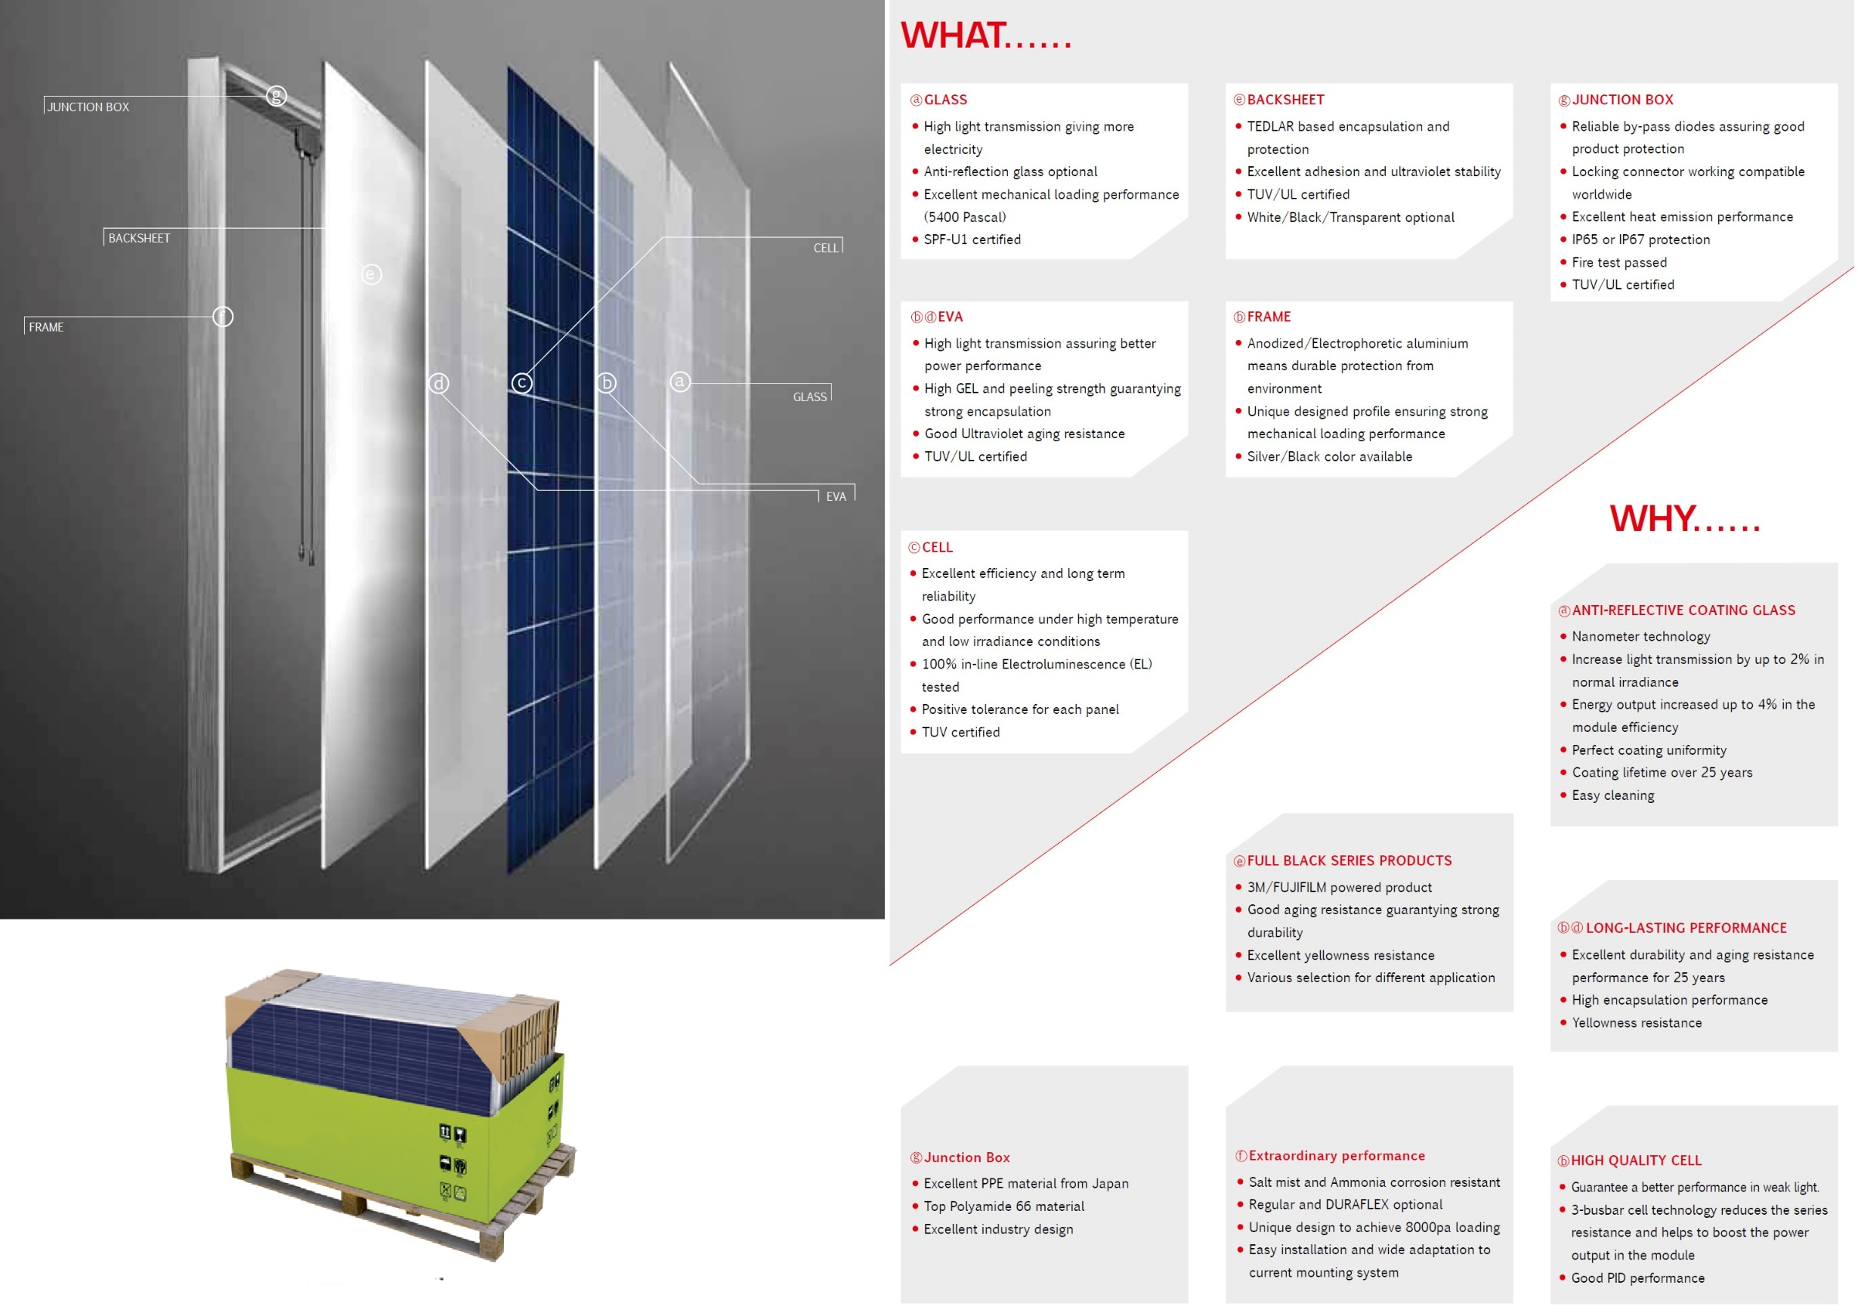

5 x BlueSolar Charge Controller MPPT 75/15
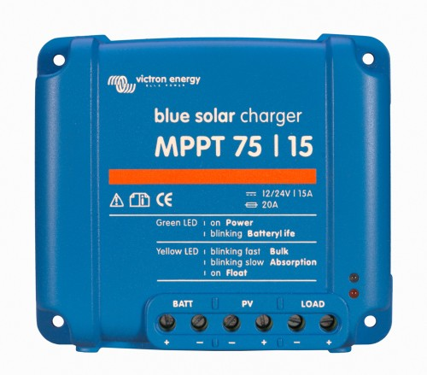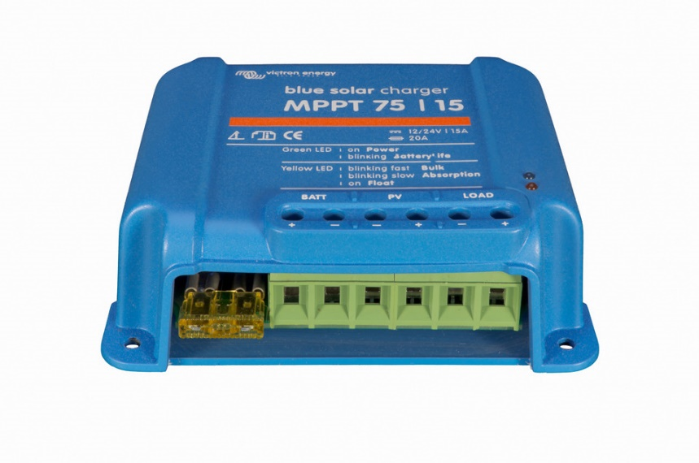
Ultra-fast Maximum Power Point Tracking (MPPT)
Especially in case of a clouded sky, when light intensity is changing continuously, an ultra-fast MPPT
controller will improve energy harvest by up to 30% compared to PWM charge controllers and by up to 10% compared to slower MPPT controllers.
Load output
Over-discharge of the battery can be prevented by connecting all loads to the load output. The load output
will disconnect the load when the battery has been discharged to a pre-set voltage.
Alternatively, an intelligent battery management algorithm can be chosen: see Battery Life.
The load output is short circuit proof.
Some loads (especially inverters) can best be connected directly to the battery, and the inverter remote
control connected to the load output. A special interface cable may be needed, please see the manual.
Battery Life: intelligent battery management
When a solar charge controller is not able to recharge the battery to its full capacity within one day, the result is often that the battery will continually be cycled between a ‘partially charged’ state and the ‘end of discharge’ state. This mode of operation (no regular full recharge) will destroy a lead-acid battery within weeks or months.
The Battery Life algorithm will monitor the state of charge of the battery and, if needed, day by day slightly increase the load disconnect level (i.e. disconnect the load earlier) until the harvested solar energy is sufficient to recharge the battery to nearly the full 100%. From that point onwards the load disconnect level will be modulated so that a nearly 100% recharge is achieved about once every week.
Programming, real-time data and history display options
- Modern Apple and Android smartphones, tablets, macbooks and other devices: see the VE.Direct Bluetooth Smart dongle and the MPPT app discovery sheet for screenshots.
- ColorControl panel
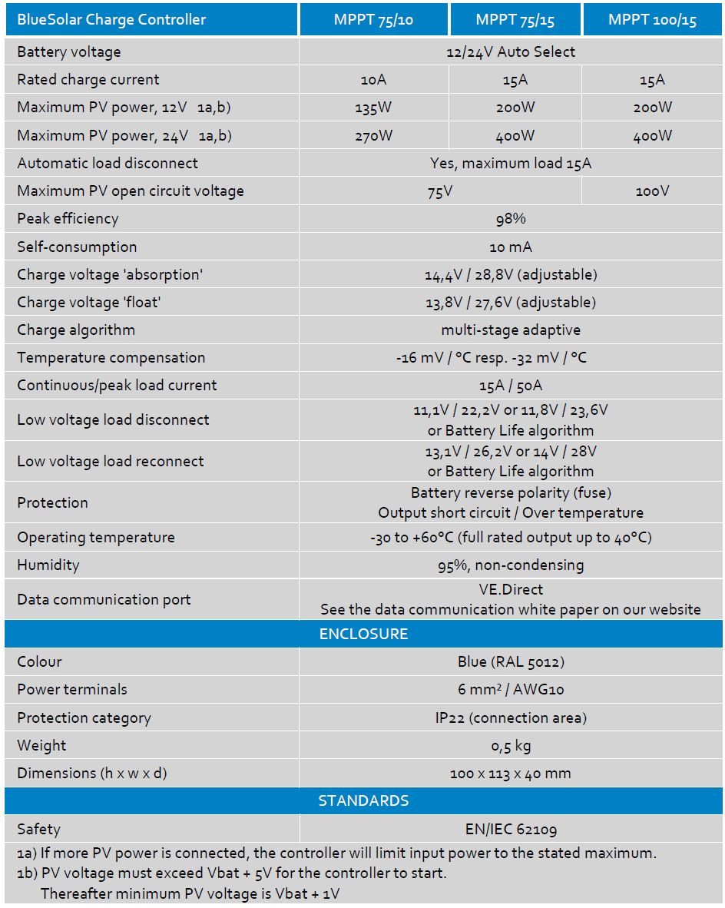

1 x BMV-700 Precision Battery Monitoring
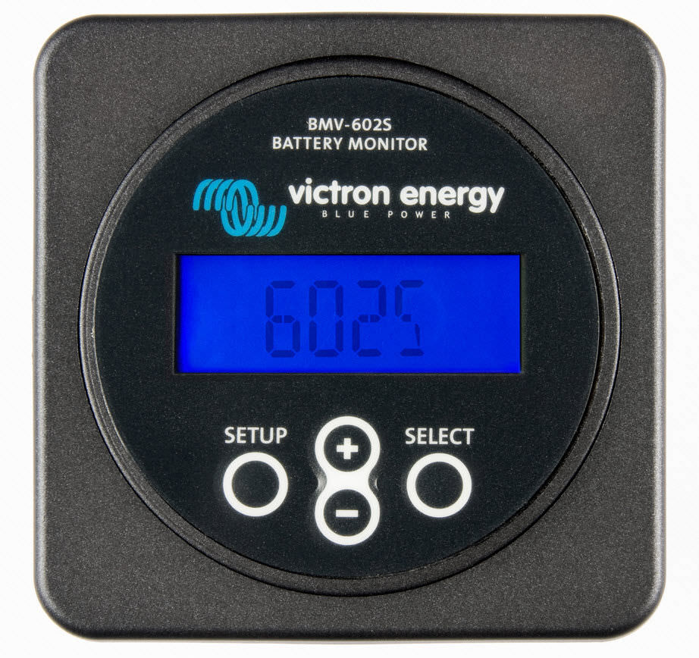
Battery ‘fuel gauge’, time-to-go indicator, and much more
The remaining battery capacity depends on the ampere-hours consumed, discharge current, temperature and
the age of the battery. Complex software algorithms are needed to take all these variables into account.
Next to the basic display options, such as voltage, current and ampere-hours consumed, the BMV-700 series
also displays state of charge, time to go, and power consumption in Watts.
Bluetooth Smart
Use the Bluetooth Smart dongle to monitor your batteries on Apple or Android smartphones, tablets,
macbooks and other devices.
Easy to install
All electrical connections are to the quick connect PCB on the current shunt. The shunt connects to the
monitor with a standard RJ12 telephone cable. Included: RJ 12 cable (10 m) and battery cable with fuse (2 m);
no other components needed.
Also included are a separate front bezel for a square or round display appearance, a securing ring for the rear
mounting and screws for the front mounting.
Easy to program (with your smartphone!)
A quick install menu and a detailed setup menu with scrolling texts assist the user when going through the
various settings.
Alternatively, choose the fast and easy solution: download the smartphone app (Bluetooth Smart dongle
needed)
Standard features
- Battery voltage, current, power, ampere-hours consumed and state of charge
- Remaining time at the current rate of discharge
- Programmable visual and audible alarm
- Programmable relay, to turn off non critical loads or to run a generator when needed
- 500 Amp quick connect shunt and connection kit
- Shunt selection capability up to 10.000 Amps
- VE.Direct communication port
- Stores a wide range of historical events, which can be used to evaluate usage patterns and battery health
- Wide input voltage range: 9,5 – 95V
- High current measurement resolution: 10 mA (0,01A)
- Low current consumption: 2,9Ah per month (4mA) @12V and 2,2Ah per month (3mA) @ 24V
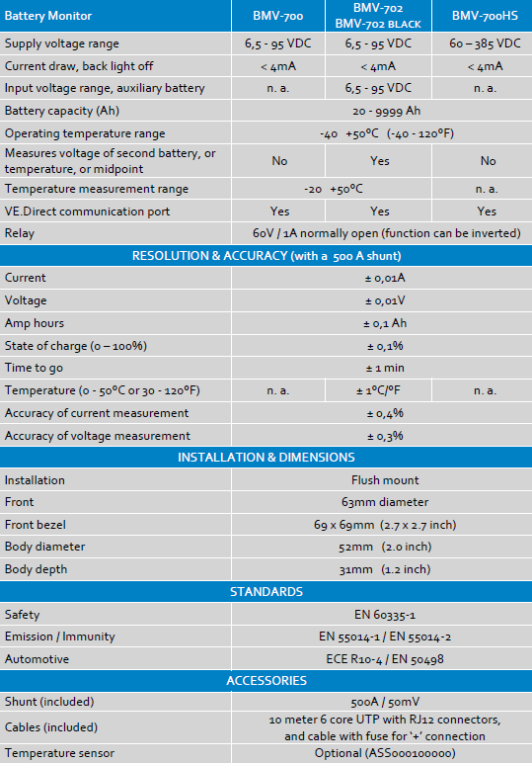

4 x Victron AGM battery 220Ah
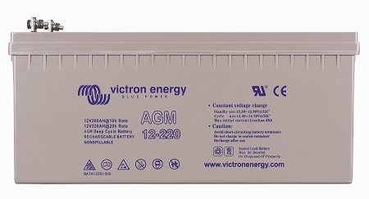
VRLA technology
VRLA stands for Valve Regulated Lead Acid, which means the batteries are sealed. Gas will escape through the safety valves only
in case of overcharging or cell failure.
VRLA batteries are maintenance free for life.
Sealed (VRLA) AGM Batteries
AGM stands for Absorbent Glass Mat. In these batteries the electrolyte is absorbed into a glass-fibre mat between the plates by
capillary action. As explained in our book ‘Energy Unlimited’, AGM batteries are more suitable for short-time delivery of very high
currents (engine starting) than gel batteries.
Low Self-Discharge
Because of the use of lead calcium grids and high purity materials, Victron VRLA batteries can be stored during long periods of
time without recharge. The rate of self-discharge is less than 2% per month at 20°C. The self-discharge doubles for every increase
in temperature by 10°C.
Victron VRLA batteries can therefore be stored for up to a year without recharging, if kept under cool conditions.
Exceptional Deep Discharge Recovery
Victron VRLA batteries have exceptional discharge recovery, even after deep or prolonged discharge.
Nevertheless repeatedly deep and prolonged discharge, have a very negative effect on the service life of all lead acid batteries,
Victron batteries are no exception.
Battery Discharging Characteristics
The rated capacity of Victron AGM and Gel Deep Cycle batteries refers to 20 hour discharge, in other words: a discharge current
of 0,05 C.
The rated capacity of Victron Tubular Plate Long Life batteries refers to 10 hours discharge.
The effective capacity decreases with increasing discharge current (see table below). Please note that the capacity reduction will be
even faster in case of a constant power load, such as an inverter.
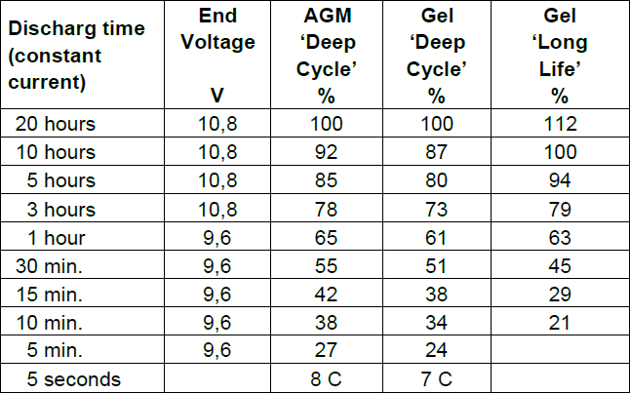
Effective capacity as a function of discharge time
(the lowest row gives the maximum allowable 5 seconds discharge current)
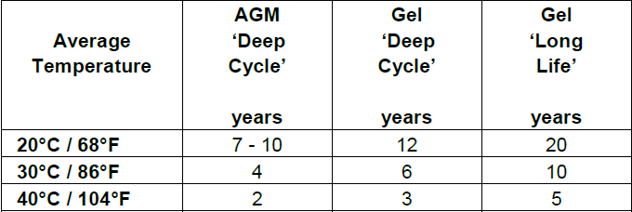
Design service life of Victron batteries under float service
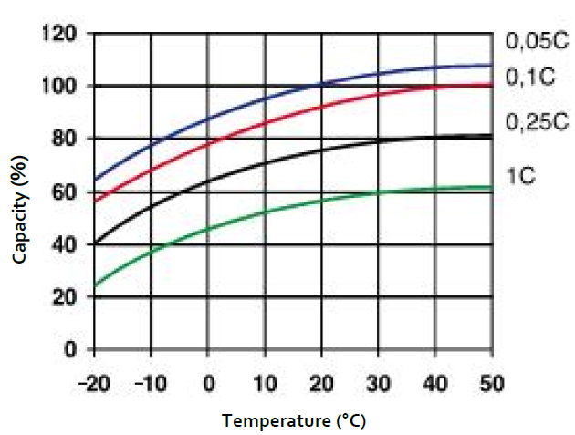
Effect of temperature on capacity
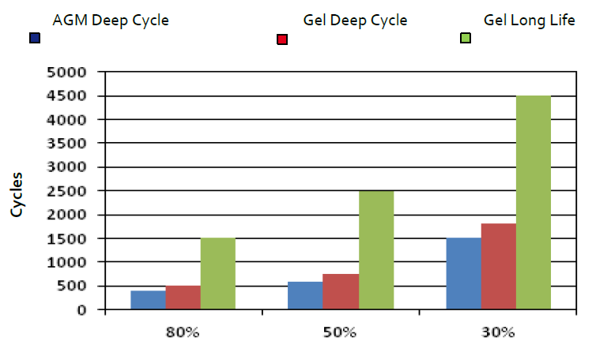
Cycle life
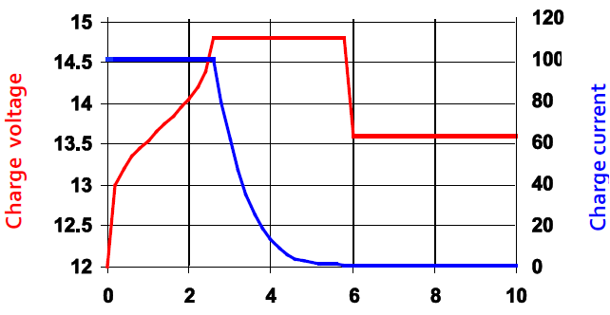
Three step charge curve
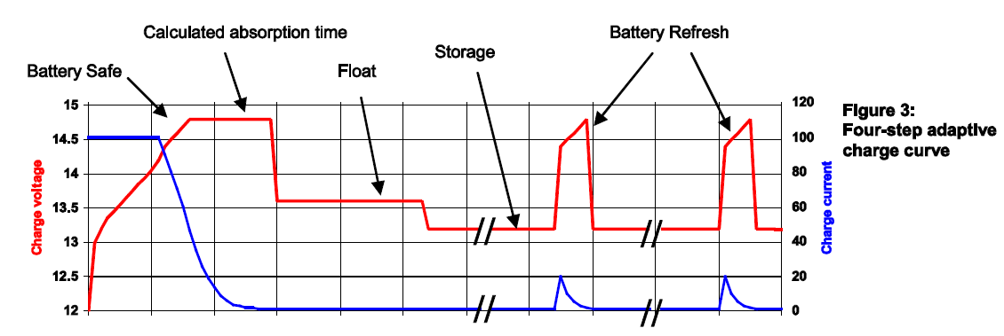
Four-step adaptive charge curve
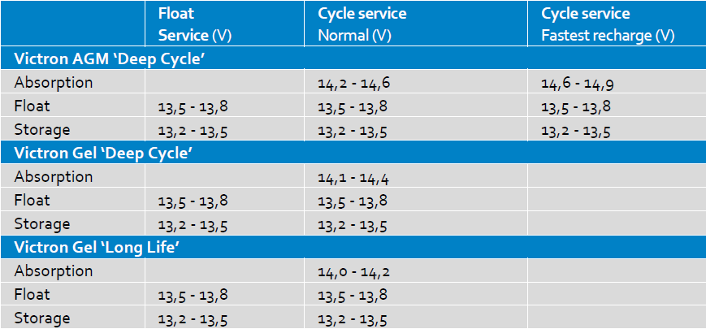
Recommended charge voltage
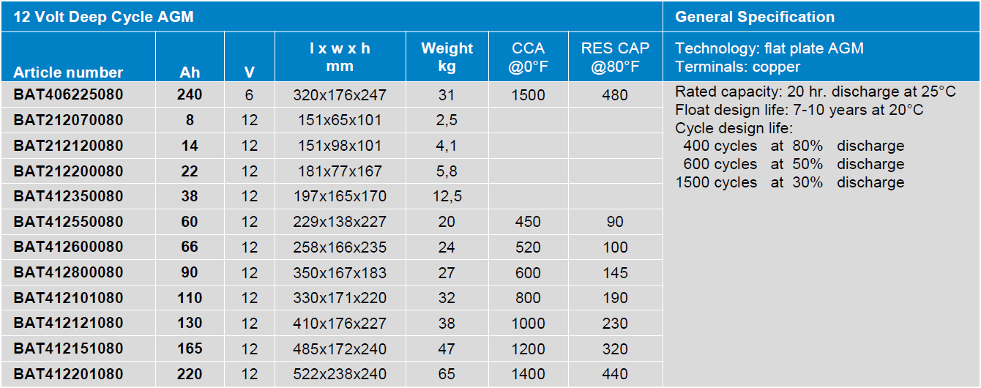

1 x Inverter Phoenix 3000/24
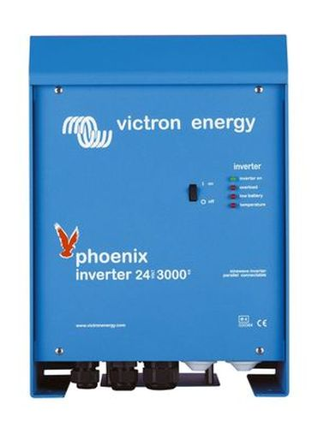
SinusMax - Superior engineering.
Developed for professional duty, the Phoenix range of inverters is suitable for the widest range of applications.
The design criteria have been to produce a true sine wave inverter with optimised efficiency but without compromise in performance.
Employing hybrid HF technology, the result is a top quality product with compact dimensions, light in weight and capable of supplying power, problem-free, to any load.
Extra start-up power.
A unique feature of the SinusMax technology is very high start-up power. Conventional high frequency
technology does not offer such extreme performance. Phoenix inverters, however, are well suited to power up
difficult loads such as refrigeration compressors, electric motors and similar appliances.
Virtually unlimited power thanks to parallel and 3-phase operation capability.
Up to 6 units inverters can operate in parallel to achieve higher power output. Six 24/5000 units, for example,
will provide 24kW / 30kVA output power. Operation in 3-phase configuration is also possible.
To transfer the load to another AC source: the automatic transfer switch.
If an automatic transfer switch is required we recommend using the MultiPlus inverter/charger instead. The
switch is included in these products and the charger function of the MultiPlus can be disabled. Computers and
other electronic equipment will continue to operate without disruption because the MultiPlus features a very
short switchover time (less than 20 milliseconds).
Computer interface.
All models have a RS-485 port. All you need to connect to your PC is our MK2 interface (see under accessories).
This interface takes care of galvanic isolation between the inverter and the computer, and converts from RS-485
to RS-232. A RS-232 to USB conversion cable is also available. Together with our VEConfigure software, which
can be downloaded free of charge from our website, all parameters of the inverters can be customised. This
includes output voltage and frequency, over and under voltage settings and programming the relay. This relay
can for example be used to signal several alarm conditions, or to start a generator. The inverters can also be
connected to VENet, the new power control network of Victron Energy, or to other computerised monitoring
and control systems.
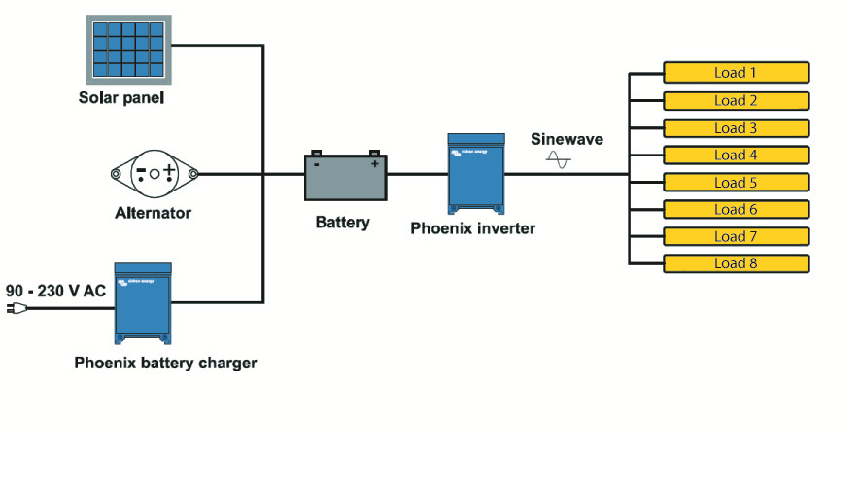
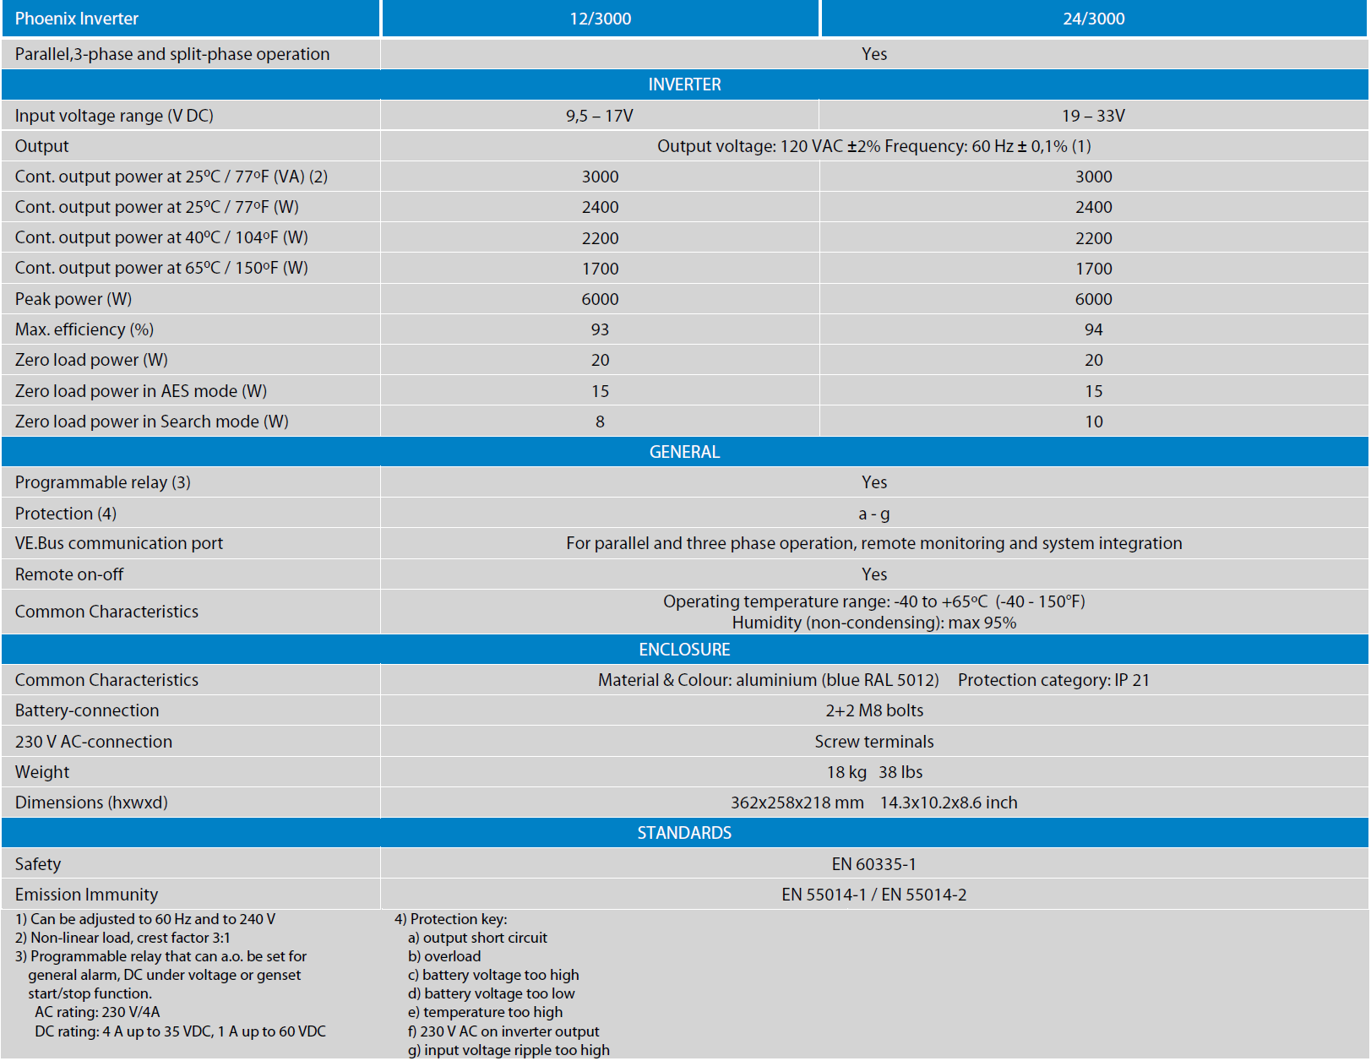

1 x Electrical PV switchgear IP55 PV 1MPPT AC/DC B+C
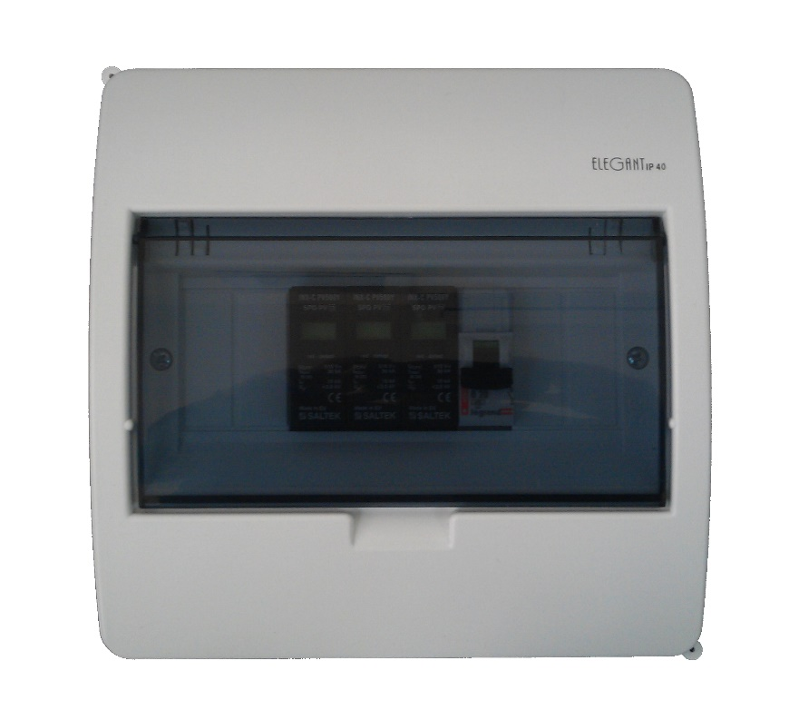
Electrical switchgear with a complete set of security photovoltaic installation.
Designed for a photovoltaic system with an inverter with 1 MPPT in the facility with the installation of lightning protection
The PV switchgear includes a device to protect the photovoltaic panels and the inverter in installation against
overvoltage in the DC circuit caused by lightning and short circuit on AC input to the inverter.
Technical Specifications:
- Protection against the overvoltage B + C type. The maximum voltage of the DC - 700V
- Protection against overcurrent-type B. Maximum current: 6-32, selected to the power of the inverter.
- Housing surface mounted IP55
- A set of cable suppressor
- Terminal N
- Terminal PE
- Wiring diagram of a photovoltaic system, security and public network

Solarflex-X PV1-F 4,0mm ~ 100m
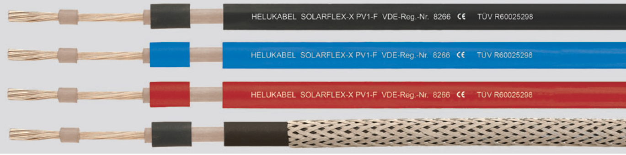
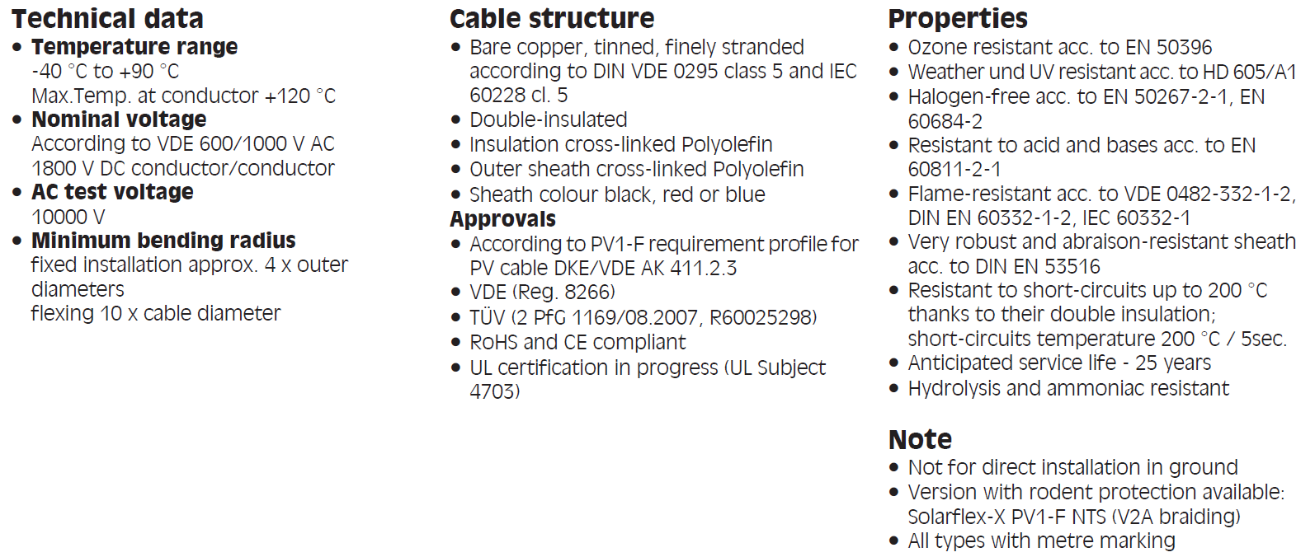

MC4 connectors
